Trade of Metal Fabrication
Module 2: | Thermal Processes
Unit 6: | Oxy/Acetylene Welding
 | Phase 2

Table of Contents
List of Figures 5
List of Tables 6
Document Release History 7
Module 2 – Thermal Processes 8
Unit 6 – Oxy/Acetylene Welding 8
Learning Outcome: 8
Key Learning Points: 8
Training Resources: 9
Key Learning Points Code: 9
Welding Techniques 10
The Leftward Technique of Gas Welding 10
Nozzle Sizes and Gas Pressures 11
The Rightward Technique of Gas Welding 12
Safety 16
Gas Cylinders 16
Pressure Regulators 17
Hoses 18
Flame Traps 18
Blowpipes 19
Backfire 19
Fluxes 19
Protective Clothing 19
Welding and Cutting Drums and Containers 20
Ventilation 20
Fire 20
Nozzle Size 21
Welding Technique 22
Torch Angle 22
The Oxy-Acetylene Flame 23
Welding Demonstration 2 – The Structure of the Oxy-Acetylene Flame 24
Automatic Pressure Regulators 25
The Pressure Gauge 28
Welding Torches 28
Self Assessment 29
Answers to Questions 1-5. Module 2.Unit 6 31
Index 35

List of Figures
Figure 1 - The Leftward Technique of Gas Welding 10
Figure 2 - The Rightward Technique of Gas Welding 13
Figure 3 - All-Position Rightward Welding 14
Figure 4 - Vertical Welding, Single-Operator for Plate Thicknesses up to 5.0 mm (3/16 in.) 15
Figure 5 - Gas Cylinder 16
Figure 6 - Pressure Regulators 17
Figure 7 - Types of Joint 22
Figure 8 - The Oxy-Acetylene Flame Showing the Various Zones 23
Figure 9 - Neutral Flame 24
Figure 10 - Carburising Flame 24
Figure 11 - Oxidising Flame 24
Figure 12 - Pressure Regulators 25
Figure 13 - Single-Stage Regulators 26
Figure 14 - Bourdon Tube Pressure Gauge 28

List of Tables
Table 1 - Typical Nozzle Sizes and Gas Pressures for Oxyacetylene Welding 11
Table 2 - Edge Preparations for Different Thicknesses of Plate 12

Document Release History
Date | Version | Comments
31/10/06 | First draft
05/12/06 | Implemented edits from Kenny.
13/12/13 | SOLAS transfer

Module 2 – Thermal Processes

Unit 6 – Oxy/Acetylene Welding
Duration – 4 Hours

Learning Outcome:
By the end of this unit each apprentice will be able to:
- Identify and assemble Oxy/Acetylene station – Gauges – Hoses – Torch (shank, mixers, nozzles)
- Adjust pressure regulators to correct settings
- Light and adjust flame – use correct shutdown procedure
- Identify and state safety standards and precautions related to oxy/fuel welding
- Identify different size nozzles and explain their uses
- Deposit a series of bead welds with and without filler rod

Key Learning Points:
Rk | Gas pressures and their regulation.
Rk | Types of nozzles and their uses.
Rk Sk | Lighting and adjusting flame (neutral, carburising and oxidising flame).
Rk Sk | Welding techniques – torch angle.
Sc | Flame temperatures – critical temperatures for mild steel.
Rk H | Safety precautions – welding in confined places.  (See “General Safety Precautions and Fire Prevention” section in Module 2 Unit 5).
H Rk | Weld symbol identification.  (See “Weld Symbols” section in Module 2 Unit 5).
Rk | Types of joints – Tack welding.
Rk | Weld pool formation – introduction of filler rod.
Rk H | Hazard identification and safety precautions.  (See “General Safety Precautions and Fire Prevention” section in Module 2 Unit 5).
P | Communication and safety awareness.

Training Resources:
- Fabrication workshop facilities, apprentice toolkit
- Oxy/Acetylene welding equipment – safety clothing and equipment – handouts – films

Key Learning Points Code:
M = Maths D= Drawing RK = Related Knowledge Sc = Science
P = Personal Skills Sk = Skill H = Hazards

Welding Techniques

The Leftward Technique of Gas Welding
When you have mastered the technique of lighting the blowpipe and adjusting the neutral flame correctly, you will be ready to practise the leftward technique of gas welding. This will usually involve some practice, under supervision, on scrap pieces of material.
The first stage is to deposit a straight bead of weld on a single piece of material and then, when you have perfected this, to practise joining two pieces. The ultimate aim is to achieve a standard of weld quality that will enable you to produce the required test pieces, if you want to become a qualified welder.
The leftward method of gas welding is used for welding steel plate up to 5 mm in thickness. It can also be used for welding non-ferrous metals.
When the blowpipe is held in the right hand, the weld travels from right to left, with the filler rod in front of the nozzle (Figure 1). The inner cone of the flame, which should be in the neutral condition for welding mild steel, is held close to the metal but not touching it.
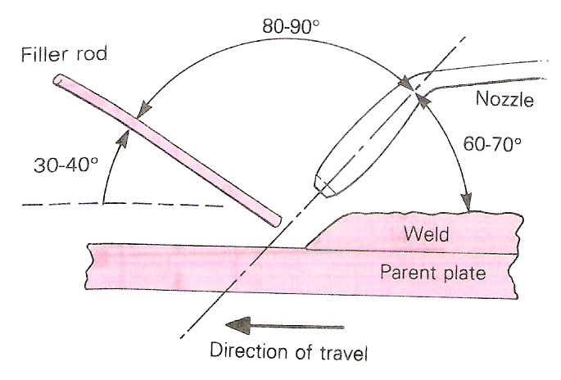
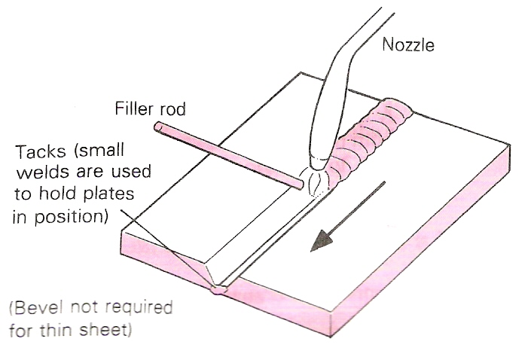
Figure 1 - The Leftward Technique of Gas Welding
For the best welding conditions, the blowpipe and filler rod should be held at approximately the angles shown in Figure 1. The nozzle is given either circular or slight side-to-side movements in order to obtain good and even fusion at the sides of the weld.
To commence welding by this technique, play the flame on the start of the joint until a molten pool is formed. Welding then proceeds by filler rod being fed or dipped into the molten pool. The rod is melted by this dipping action and not by the flame itself.
Do not hold the filler rod continuously in the molten pool, as this could prevent the heat of the flame and thus the molten pool from reaching the lower parts of the weld joint, resulting in possible lack of fusion.

Nozzle Sizes and Gas Pressures
As the thickness of the work increases, the flame will be required to supply more heat. This is made possible by increasing the nozzle size and the regulator gas pressures (in accordance with manufacturers’ instructions).
If you try to weld thick metal with a small nozzle by increasing the gas pressure, there comes a point where the flame leaves the end of the nozzle. This indicates that the pressure is too high, resulting in a very noisy flame. It is much better to work with a 'soft' flame, which is obtained by using the correct nozzle size and pressure settings.
At the other extreme, if you try to weld with a nozzle that is too large for the work, by reducing the supply of gas at the blowpipe valves instead of changing to a smaller nozzle, then small explosions will occur at the nozzle. This is because the gas tends to build up round the nozzle in small bubbles. These small explosions indicate that the gas pressure is too low.
Table 1 lists typical nozzle sizes and gas pressures for oxyacetylene welding. Always consult the manufacturer’s information, as this information can vary slightly with different makes of blowpipe.

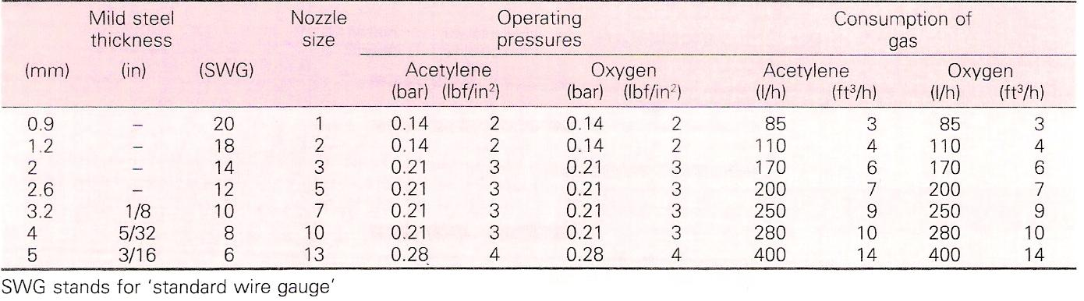
Table 1 - Typical Nozzle Sizes and Gas Pressures for Oxyacetylene Welding

The Rightward Technique of Gas Welding
As the plates get thicker, different edge preparations are employed. These different edge preparations are shown in Table 2. Notice that as the plate gets more than 4 mm thick, it is recommended that another technique, the rightward technique, is used.

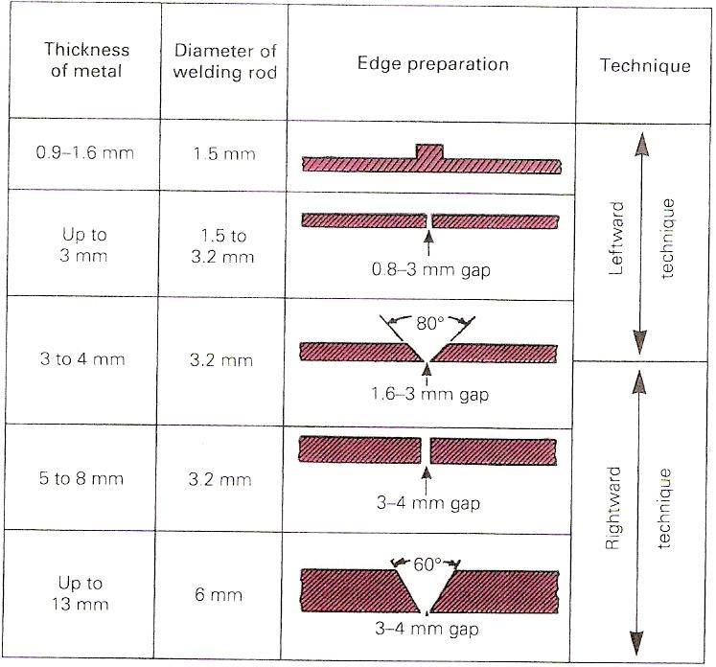
Table 2 - Edge Preparations for Different Thicknesses of Plate
Above 13mm thickness, plate can be bevelled and welded from both sides.

These days it is more usual to use one of the arc welding processes on materials above 4 mm thickness, but the rightward method is handy to know. Some welding courses include it, and a brief description is given here.
The rightward technique is shown in Figure 2. Some of the advantages of this method on thicker plate are as follows:

- It is faster and uses less filler rod, so it is less expensive.
- There is less expansion and therefore less contraction.
- The flame remains over the deposited metal, giving an annealing action.
- A better view of the molten pool is obtained, allowing for greater control of the welding operation.

Gas welding can be used for positional welding (welding in the vertical and overhead positions). These notes cover the flat position only, as you will need to perfect this technique thoroughly before you can learn positional welding.

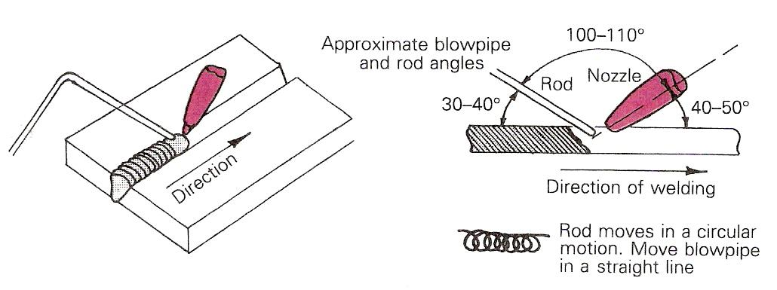
Figure 2 - The Rightward Technique of Gas Welding

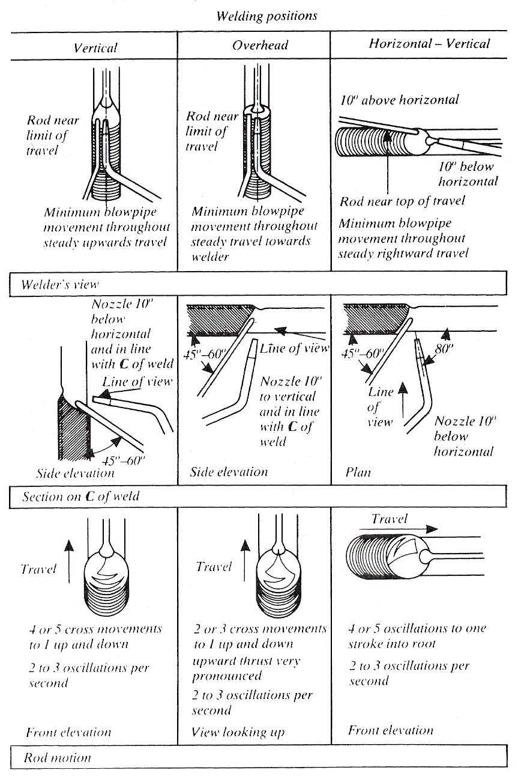
Figure 3 - All-Position Rightward Welding

Butt welds in mild steel 5 to 8 mm (3/16 to 5/16 in.) thick.

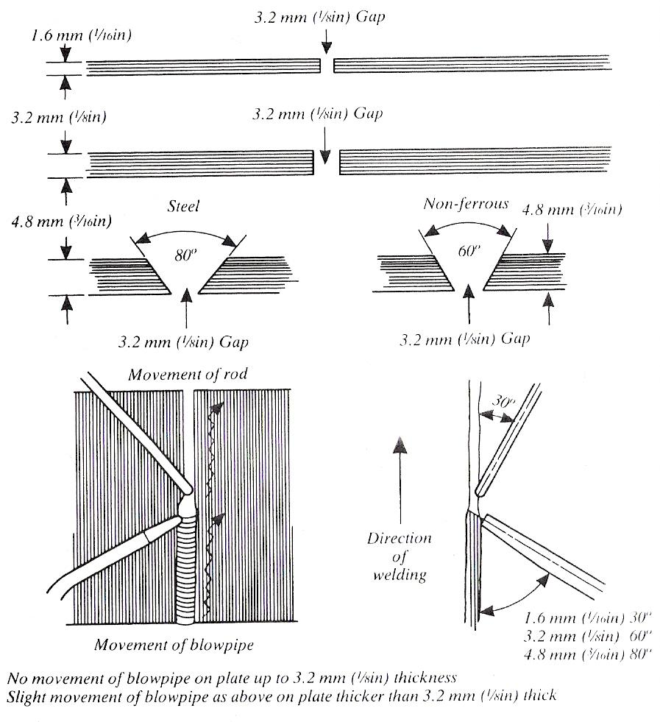
Figure 4 - Vertical Welding, Single-Operator for Plate Thicknesses up to 5.0 mm (3/16 in.)

Safety
BOC supplies equipment which is manufactured to the highest standards of quality and safety and will give first-class service for many years if operated correctly. The following notes will help to ensure your equipment is efficient and safe. Some suggestions for personal safety are also included. It is not intended to list every possible safeguard. These notes must be supplemented by caution and common sense on the part of the individual. Remember familiarity breeds over-confidence.
Safety precautions to be observed when using compressed gases with welding and cutting equipment are described in the companion booklet, "Safe Under Pressure" available from your nearest BOC branch or Cylinder Centre. Data Sheets and a Cylinder Identification Wall Chart are also available.

Gas Cylinders
Leakage around the spindle of the cylinder valve will be revealed by hissing and in the case of fuel gases, by a smell. Tighten the gland nut (Figure 5) on the cylinder valve slightly with a spanner (clockwise) and test with 1 % solution of Teepol® HB7 in water. If still leaking, do not use the cylinder but label and return it. If the cylinder is owned by BOC, BOC will carry out an examination and replace it. NEVER USE A FLAME WHEN TESTING FOR LEAKS.
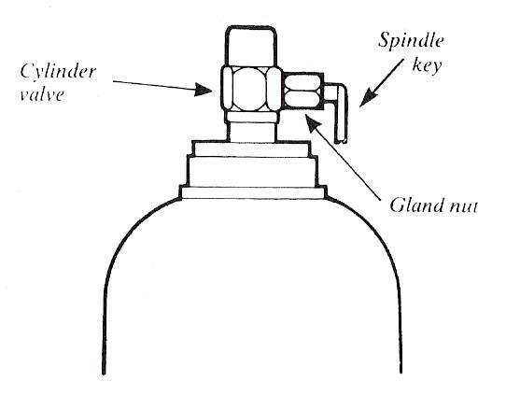
Figure 5 - Gas Cylinder

Pressure Regulators
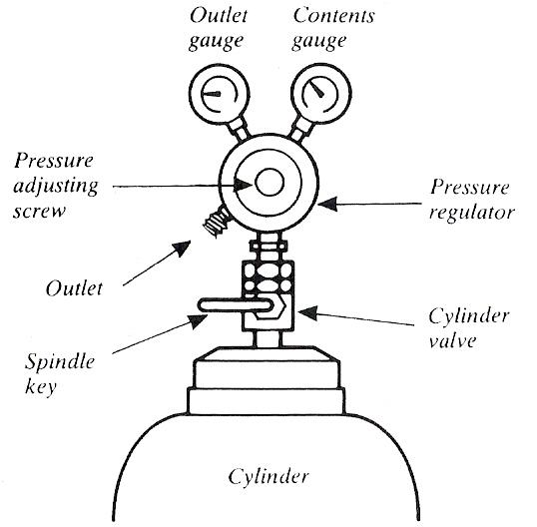
Figure 6 - Pressure Regulators

Always treat a pressure regulator as a precision instrument. Do not expose it to knocks, jars or sudden pressure surges caused by the rapid opening of the cylinder valve. Always open the cylinder valve slowly and smoothly using the special Spindle Key. Periodically check the bullnose seating on the pressure regulator. If the seating is damaged, it will leak gas. The pressure regulator should be replaced immediately.

Never use a pressure regulator with other than the gas for which it was designed. Release pressure using the pressure adjustment screw when shutting down, after cylinder valves have been closed and pressure in the hose has been released.

If gauge pointers do not return to zero when the pressure is released, the mechanism is faulty and the regulator should be replaced.

If the regulator "creeps" (passes gas when the pressure adjustment screw is released, or builds up on the low pressure side when the blowpipe valve is shut) it should be replaced. Ask for details of the BOC Service Exchange Scheme for safety and economy.

Do not attempt to repair regulators.

Hoses
Use hose which is in good condition and manufactured to the correct specification. Hoses should be fitted with the correct end connections attached by permanent clips.
Do not expose hoses to heat, traffic, slag, sparks, oil, grease, or sharp edges of metal. Test for leakage at working pressure by immersing in water; leaks may be repaired by cutting out a faulty section of hose and inserting an approved coupling. Never use copper couplings with acetylene. Doing so could permit the formation of copper acetylide. Worn ends should be cut back and re-fitted with hose connectors using permanent clips.
In general, do not fit more than two or three couplings in a length of hose. Consider replacing the hose entirely, as parts are likely to be perished or damaged.
Ensure hoses are not wrapped around cylinders when stored or in use.
Hose check valves are supplied by BOC with fitted hose. The hose check valve is an automatic safeguard, incorporating a spring-loaded non-return valve. Its purpose is to inhibit oxygen and fuel gases mixing in the hoses. The hose check valve has reduced the incidence of backfeeding in which oxygen contaminates fuel gas hose or vice versa. It is essential to ensure that your welding and cutting equipment is protected, as far as possible, against backfeeding which may cause extensive damage to hoses and regulators in the event of a flashback.
Hose check valves (for fitting to the blowpipe end of the hoses) are available from BOC Cylinder Centres, and should always be used with welding and cutting equipment.

Flame Traps
Flame traps are designed to give automatic protection to personnel and equipment against the hazard of mixed gas explosions in gas welding or cutting equipment. The explosion (flashback) can occur when backfeeding of gases has taken place. A mixture of gases is then present in either the oxygen or fuel gas hose, and if the operator fails to purge the hoses sufficiently, a flashback can occur when the blowpipe is ignited.
Flashback can be avoided by adhering to recommended operating procedures and the use of flame traps does not enable the operator to ignore good operating practices.
Approved flame traps, covering a variety of industrial requirements, are available from BOC Cylinder Centres.
It is recommended that approved flame traps are installed in both the oxygen and the fuel gas lines immediately downstream of the pressure regulator. Hoses supplied with Portapak outfits are already fitted with flame traps incorporating non return valves as recommended in the BCGA Code of Practice CP7.

Blowpipes
Gas leaks can be detected by 1% Teepol® or proprietary leak detection solutions or hissing and, in the case of fuel gases, also by smell. Leaks at the head nut or welding nozzle should be cured by cleaning the seat with a soft cloth. If the leak continues, the blowpipe should be replaced.
Do not carry out blowpipe repairs. Ask about Service Exchange at your local BOC Cylinder Centre.

Backfire
For a variety of reasons e.g. incorrect operating conditions, nozzle blockage etc., the flame may backfire into the blowpipe. Usually the flame can be re-lit immediately.
In a small number of instances the flame may continue to burn inside the blowpipe, a condition called sustained backfire. This can be recognised by a roaring, rushing sound, and the body of the blowpipe will become very hot. Rapid action is necessary to prevent permanent damage to the blowpipe, Close the blowpipe oxygen valve, then the blowpipe acetylene valve, and allow the blowpipe to cool - it can be plunged into a bucket of water. Check the nozzle for tightness, check gas pressures on the pressure regulators, purge the hoses and if everything looks correct, begin the lighting up procedure,
If sustained backfire recurs, the nozzle or blowpipe or both require replacement.

Fluxes
Fluxes must only be used in a well ventilated area.

Protective Clothing
Goggles should be worn at all times whilst welding and cutting and should conform to the Protection of Eyes Regulations, BOC will advise you of goggles suitable for your type of work.
Leather or suitable protective clothing should be worn for heavy cutting or welding. The feet should be protected from sparks, slag or falling off-cuts.
Teepol is a registered trade mark of Shell.

Welding and Cutting Drums and Containers
Welding or cutting drums, containers or tanks which have held flammable liquids or gases can be dangerous, even though they are supposed to be clean and free from explosive vapour or liquids. BOC will advise you on suitable precautions.
Do not weld hollow vessels before establishing that confined air is properly vented; hollow metal parts should be drilled to prevent explosions caused by heat.

Ventilation
In a confined space, ensure that there is a suction fan to give adequate ventilation (a fume hood, at the source of fumes, is the best method); DO NOT USE OXYGEN OR AN AIR BLOWER and always post a trained helper outside for emergencies. Test all equipment for leaks before entering, and remove the equipment outside during periods when it is not in use and on completion of daily work. The welding of brass or galvanised materials should be carried out in well ventilated areas and if the work is likely to be prolonged suitable breathing apparatus should be worn.
When cutting painted or galvanised steel, unless ventilation is very good, fume extraction should be installed at the point of cutting. In some cases it may be necessary to wear a respirator as well.

Fire
Take care that there is no combustible material within reach of sparks; sparks from cutting may travel as far as 10 metres (35 feet) along a floor. Ensure that sparks and falling slag do not fall over the cylinder or hoses. If necessary protect anything in the neighbourhood of the work with sheet metal guards or fibreglass sheets down to the floor - tarpaulins do not give sufficient protection. Where it is necessary to work close to combustible material, keep fire fighting apparatus handy and post a man at the scene of the work for at least half-an-hour after the work has finished. In dusty or gassy atmospheres consult the responsible official in charge before starting work.
Clothing should be free from grease and preferably made of wool which is not so readily flammable. Goggles, collars, combs, buttons, etc., of flammable material should not be worn.

Nozzle Size
For a given welding torch, the NOZZLE OUTLET SIZE has a much greater influence on governing the flame size than changing the gas pressures on adjusting the control valves.

The manufacturers of gas welding equipment have adopted various methods of indicating nozzle sizes, such as:

- By the approximate consumption of each gas per hour.
- By the nozzle outlet bore size (orifice diameter).
- By a reference number corresponding to a metal thickness range which may be welded with a specific nozzle.

Whatever the method employed for indicating nozzle sizes there is a definite relationship between the sizes of welding nozzles and the metal thicknesses.

Manufacturer’s recommendations should always be followed with regard to nozzle sizes and gas pressures for a particular application.

Welding Technique

Torch Angle

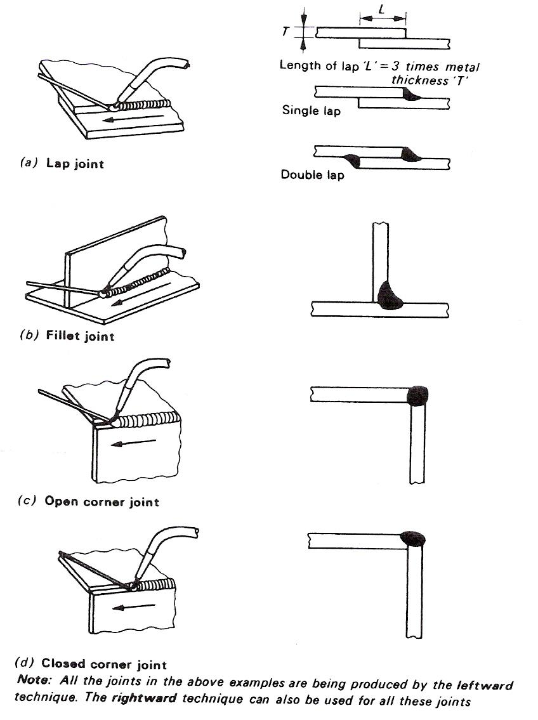
Figure 7 - Types of Joint

The Oxy-Acetylene Flame
Acetylene is composed of Hydrogen and Carbon, as are most fuel gases. It is mainly the carbon which provides the intense heat and very high flame temperature (3100°C) when burned with oxygen. If sufficient oxygen is not provided, then the carbon is given off into the air as black, sooty smuts.

Acetylene has a very high proportion of carbon in it and if the oxygen is turned down to provide a flame with excess carbon; the carbon is taken into the steel to provide a high carbon surface, used for hard surfacing operations.

A neutral oxy-acetylene flame burns equal proportions of oxygen and acetylene and is reducing in nature, thereby reducing any iron oxide to iron and taking up the oxygen; consequently there is no need to use a flux when welding steel. It should be noted that iron oxide is not refractory.

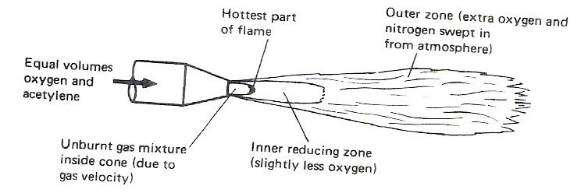
Figure 8 - The Oxy-Acetylene Flame Showing the Various Zones

Welding Demonstration 2 – The Structure of the Oxy-Acetylene Flame
AIM To demonstrate the three oxy-acetylene flame settings.
EQUIPMENT Oxy-acetylene welding equipment, including goggles and flint lighter.
THEORY There are three distinct flame settings:
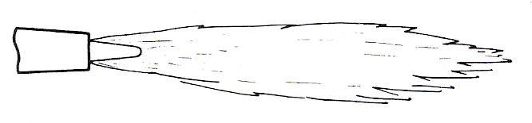
Figure 9 - Neutral Flame
Cone tip hottest part approx. 3100°C.

- Neutral Flame
This flame burns equal quantities of oxygen and acetylene. (In practice, it is advisable to have the slightest possible acetylene haze at the cone tip to begin with.)
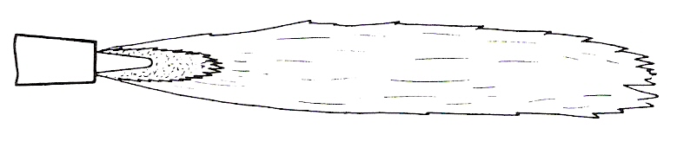
Figure 10 - Carburising Flame

- Carburising Flame
This flame has an excess of acetylene which results in a carbon-rich zone extending around and beyond the cone. Note: Both the Neutral and carburising flames are reducing in nature.
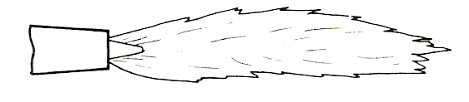
Figure 11 - Oxidising Flame

- Oxidising Flame
This flame has an excess of oxygen which results in an oxygen-rich zone just beyond the cone. This flame is obtained by setting to neutral and then turning the fuel gas down.

Automatic Pressure Regulators
These are fitted to the oxygen and acetylene cylinders to reduce the pressure and control the flow of the welding gases. Examples are shown in Figure 12. They are fitted with two pressure gauges. One indicating the gas pressure in the cylinder, and the other indicating the reduced outlet pressure. The operation of the pressure gauge is explained in the next section.
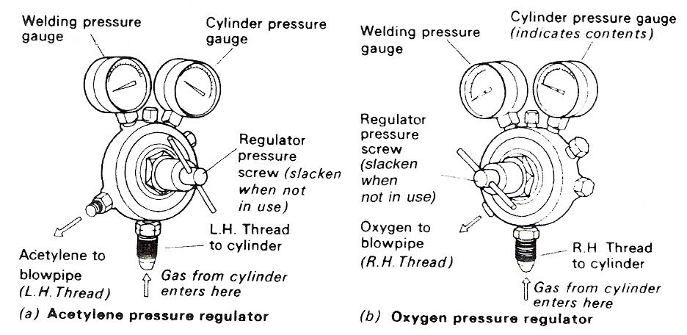
Figure 12 - Pressure Regulators

Less transportation.
More effective use of the gas.
The cylinders are easily reached in case of fire.

The four principal elements which constitute a pressure-reducing regulator are:
- A valve consisting of a nozzle and a mating seat member.
- An adjustable screw which controls the thrust of the cover spring.
- A cover spring which transmits to a diaphragm the thrust created by the adjusting screw.
- A diaphragm connected with the mating seat member.

Figure 13 illustrates two basic types of 'single-stage' regulator.
In the 'needle type' regulator the inlet pressure tends to close the seat member against the nozzle. The outlet pressure on this type of regulator has a tendency to increase somewhat as the inlet pressure decreases. This increase is caused by a decrease of the force produced by the gas pressure against the seating area as the inlet pressure decreases. This type of single-stage regulator is sometimes referred to as 'inverse' or 'negative' type.

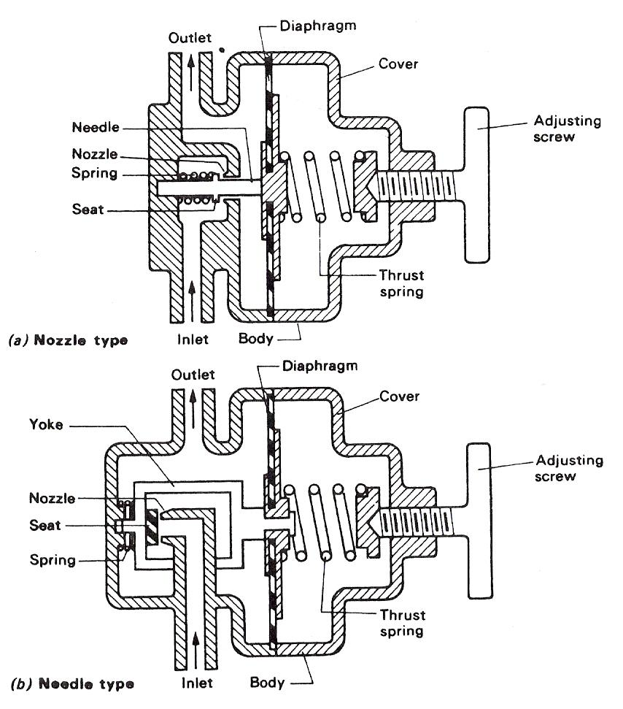
Figure 13 - Single-Stage Regulators
In the 'nozzle type' regulator the inlet pressure tends to move the seat member away from the nozzle, therefore the outlet pressure decreases somewhat as the inlet pressure decreases. This is because the force tending to move the seat member away from the nozzle is reduced as the inlet pressure decreases. This type of single-stage regulator is referred to as 'direct acting' or 'positive' type.

THE GAS OUTLET PRESSURE FOR ANY PARTICULAR SETTING OF THE ADJUSTING SCREW IS REGULATED BY A BALANCE OF FORCES. This balance is between the cover spring thrust and the opposing forces created by a combination of the outlet pressure against the underside of the diaphragm and the inlet pressure against the seating area.

When the inlet pressure decreases, its force against the seat member decreases, allowing the cover spring force to move the seat member away from the nozzle. Thus more gas pressure is allowed to build up to re-establish the balanced condition.

A smaller outlet pressure on the underside of the diaphragm is all that is necessary to close the seat member against the nozzle. The opening between the seat members and the nozzle is reduced, which results in less gas flow.

The Pressure Gauge
Inside a pressure gauge there is a BOURDON TUBE. This is a copper-alloy tube of oval section, bent in a circular arc. One end of the tube is sealed shut and attached by light linkage to a mechanism which operates a pointer. The other end is fixed, and is open for the application of the pressure which is to be measured. The internal pressure tends to change the section of the tube from oval to circular and this causes it to straighten out slightly. The resultant movement of the tube causes the pointer to move over a suitably calibrated scale. An example of a bourdon tube pressure gauge is shown in Figure 14.

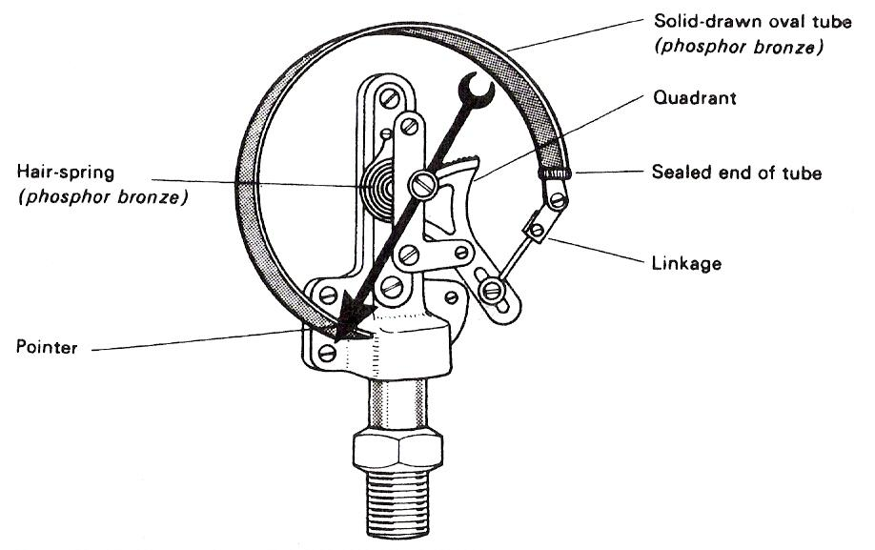
Figure 14 - Bourdon Tube Pressure Gauge

Welding Torches
The gases having been reduced in pressure by the gas regulators are fed through suitable hoses to a welding torch.

Self Assessment
Questions on Background Notes – Module 2.Unit 6

1. List some Safety Precautions when using Compressed Gas Cylinders.

2. What does the term ‘Back Fire’ mean?

- List some Safety Precautions when welding or cutting Drums or Containers.

4. What does the term ‘Neutral Flame’ mean?

5. Sketch a Pressure Regulator and show what the gauges are for and what
hand thread is on;
- Acetylene Cylinder
- Oxygen Cylinder

Answers to Questions 1-5. Module 2.Unit 6
1.

Safety Precautions when using compressed Gas Cylinders:

Never use a flame when testing for leaks.

Do not expose it to knocks or sudden pressure surges caused
by the rapid opening of the cylinder valve.

Always open the cylinder valve slowly and smoothly using
the spindle key.

Periodically check the bullnose seating on the pressure
regulator. If damaged it will leak gas, replace immediately.

Never use a pressure regulator with other than the gas it was
designed for.

If the gauge pointers do not return to zero when the pressure
is released, the mechanism is faulty, the regulator should be
replaced.

Do not attempt to repair regulators.

Use a hose in good condition and manufactured to the correct
specification.

Hoses should be fitted with the correct end connections
attached by permanent clips.
Continued.

Do not expose the hose to heat, traffic, slag, spark, oil grease
or sharp edge metal.

Test for leaks at working pressure by immersing in water. Leaks
may be repaired by cutting out a faulty section and inserting an
approved coupling.

Never use copper couplings with acetylene. Doing so could
permit the formation of copper acetylide.

Worn ends should be cut back and re-fitted with hose connectors
using permanent clips

In general, do not fit more than two or three couplings in a length
of hose.

Ensure hoses are not wrapped around cylinders when stored or
in use.

2.

Backfire:

For a variety of reasons e.g. incorrect operating conditions, nozzle blockage etc, and the flame may backfire into the blowpipe. Usually the flame can be re-lit immediately.

Continued.

Sustained Backfire occurs when the flame continues to burn inside the blowpipe. This can be recognised by a roaring, rushing sound and the body of the blowpipe will become very hot. To prevent permanent damage to the blowpipe, close the blowpipe oxygen valve, then the acetylene valve, then allow the blowpipe to cool down it can be plunged into a bucket of water.

Check the nozzle for tightness, check the gas pressure on the pressure regulators, purge the hoses and if everything looks correct, begin the lighting up procedure.

If sustained Backfire recurs, the nozzle or blowpipe or both require replacement.

3.

Safety Precautions:
Welding or cutting drums, containers or tanks which have held
flammable liquids or gases can be dangerous, even though they are
supposed to be clean and free from explosive vapour or liquids.

Do not weld hollow vessels before establishing that confined
air is properly vented; hollow metal parts should be drilled to
prevent explosions caused by heat.

4.

‘Neutral Flame’
A neutral oxy-acetylene flame burns equal proportions of
Oxygen and Acetylene.

5.

Pressure Regulator:

Figure 17: Acetylene Cylinder
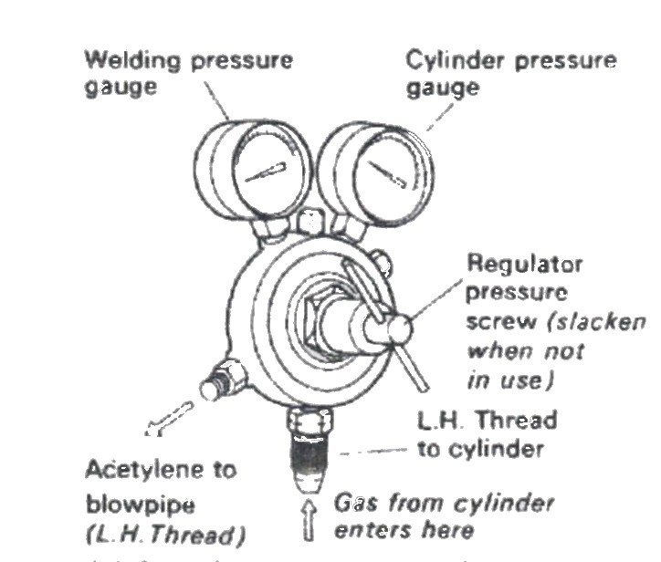

Figure 18: Oxygen Cylinder

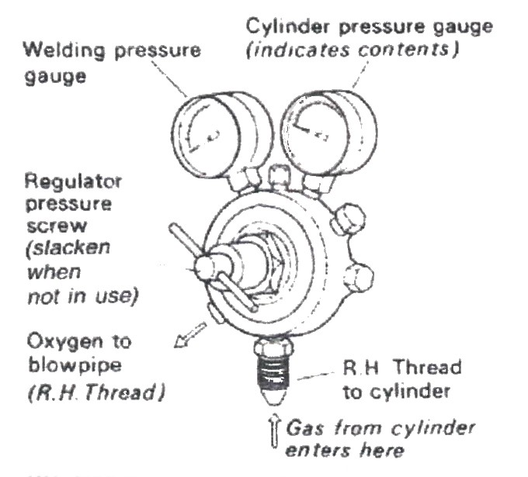

Index

A
Automatic Pressure Regulators, 25
N
Nozzle Size, 21
S
Safety, 16
Backfire, 19
Blowpipes, 19
Fire, 20
Flame Traps, 18
Fluxes, 19
Gas Cylinders, 16
Hoses, 18
Pressure Regulators, 17
Protective Clothing, 19
Ventilation, 20
Welding and Cutting Drums and Containers, 20
T
The Oxy-Acetylene Flame, 23
Welding Demonstration 2 – The Structure of the Oxy-Acetylene Flame, 24
The Pressure Gauge, 28
W
Welding Technique, 22
Torch Angle, 22
Welding Techniques, 10
Nozzle Sizes and Gas Pressures, 11
The Leftward Technique of Gas Welding, 10
The Rightward Technique of Gas Welding, 12
Welding Torches, 28

